Text for Press release of the Nawras 2010 RAHBC Oman Open HOBIE 16 Championship held at Ras al Hamra Boat Club on 23 and 24 September 2010.
=================================================================================
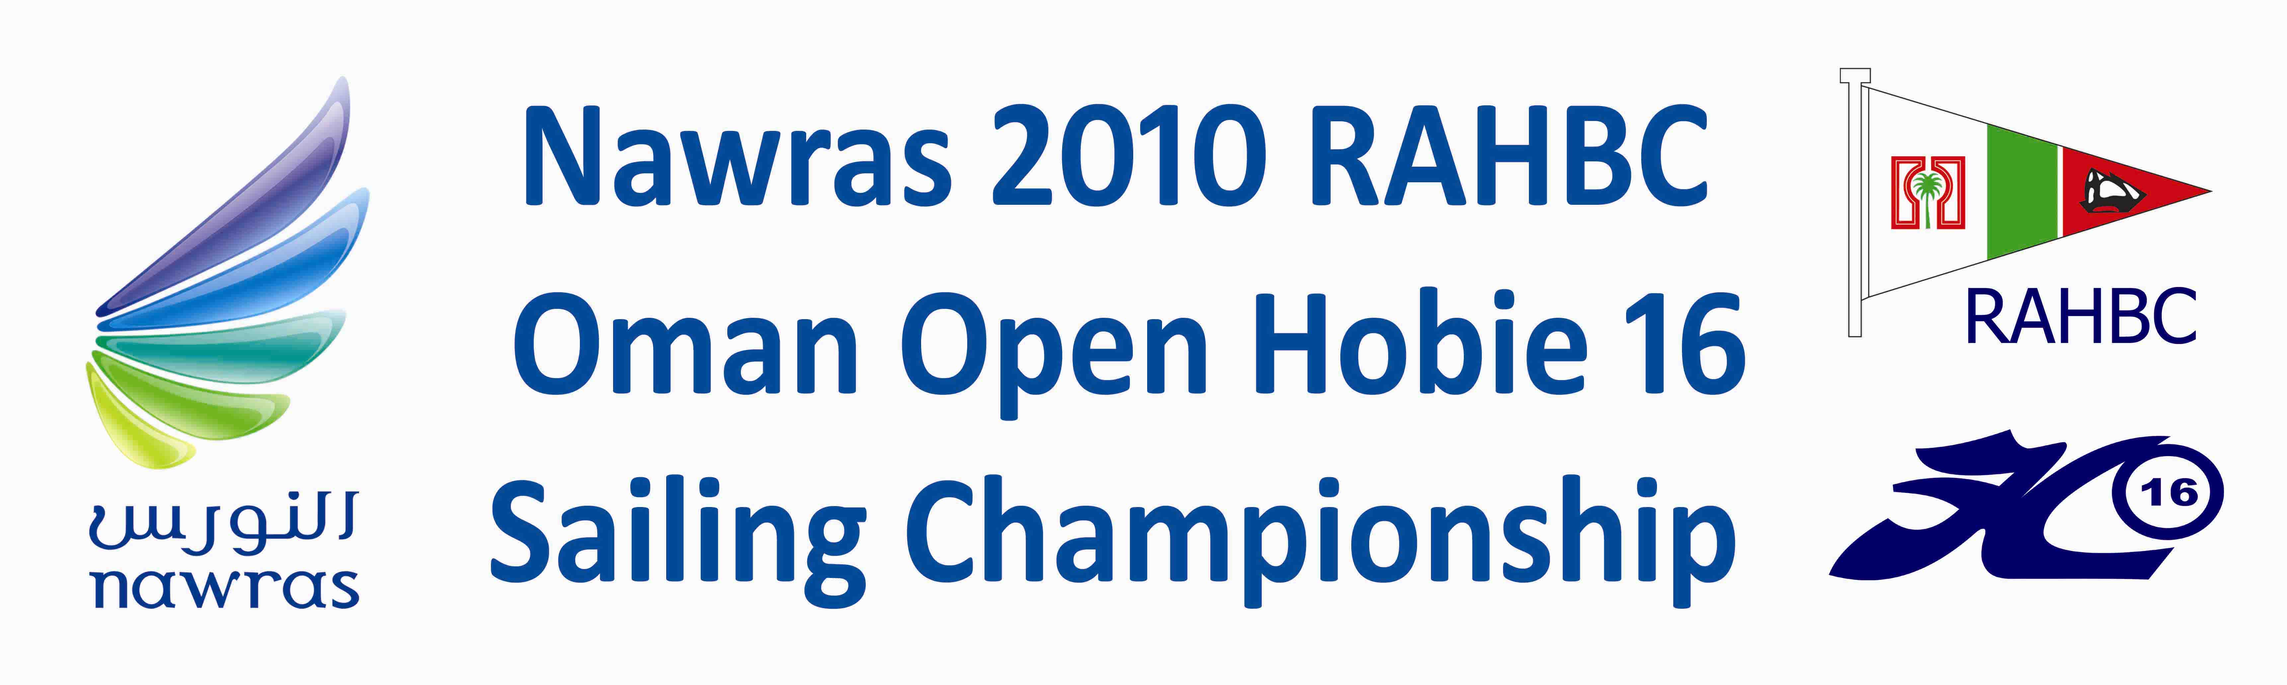
Following the successful Pre-qualification event in late August the Nawras 2010 RAHBC Oman Open Hobie 16 Sailing Championship took place over the weekend of 23rd – 24th September at the Ras Al Hamra Recreation Centre. In true form, like during the Prequals, mention the word championship and the wind disappears!
With 19 boats from RAHBC, Casteways and Oman Sail on the water there was a good turnout for the nine races which were scheduled for the weekend.
Following the pre-race briefing the Officer of the Day (OOD), George Rice of Oman Sail, took to the water in the committee boat which was supplied by Nomad Tours, to set a course in light westerly winds. The first race got underway with many competitors being cautious and shy of the line, very quickly light winds expert, Victoria Grainger, took the lead and showed the rest of the fleet the way home.
In the ever dying and shifting breeze the course was shortened and reset. Race 2 was underway way, this time Dave Clark led the way and some 20 minutes later still short of the first mark and the rest of the fleet going nowhere the OOD decided to call the race off and hoisted the “abandon race” flag. The fleet headed for the beach and lunch in the hope that the wind would pick up in the afternoon. Sadly it did not and racing was abandoned for the day.
On a very humid evening 70 crew, spouses and friends sat down to an excellent candle light dinner on the beach, with an incoming tide the occupants of several tables were concerned that they were going to be engulfed by the sea, but all was well and by midnight the beach was empty with everyone going home hoping for more wind the next day.
On Friday morning the OOD and his crew took to the water early hoping for a punctual start at 11:00, again with light north-westerly winds a course was set, the race starting sequence commenced and with 10 seconds to go the he postponed as the wind died away completely. Several boats headed for the beach with others caught in the current were being pushed towards the cliff face at Sharky’s Point. The club safety boat, skippered by Brett Hall, went to the rescue and towed them clear of danger. Meanwhile the eagle eyes on the Committee Boat spotted wind several kilometres further out towards Fahal Island so they lifted anchor and headed for the wind. With the wind meter reading 7 knots the boats were called out, a course was set and race 2 got underway, this time club member Joost Bloemarts took the lead with Dave Clark and Victoria coming in 2nd and 3rd, newcomer Simon Kay sailing with his son Dylan was up among the leaders but unfortunately in the excitement of the moment he rounded a mark the wrong way and was disqualified.
With still reasonable wind the 3rd race got underway immediately; by now the crews were becoming more confident and the start was very tight with all the boats jostling for position when the starting gun was fired. Four of the hopeful champions were over the line, the individual recall flag was flown and one gun fired. Victoria and Joost returned to the line to take their penalty and restart their race. In the meantime the other two offenders raced on either oblivious of their error, hoping it was not them or maybe they had not been spotted. As the race came to an end Dave Clark and Tony van Thiel approached the line neck and neck and, apart from infringing the rules at the finish, they were unaware that they did not get a finishing gun being the other two offenders at the start. Tony having hit the committee boat, and much to the annoyance of others decided to round it again hoping to exonerate himself and finished legally but still got no gun due to his earlier infringement of the rules. This opened the door for newcomers Johannes Boersma and David Boeyinga to take 1st and 2ndplaces followed by championship contenders Victoria and Joost in 3rd and 4thhaving worked their way through the fleet.
With the likelihood of the wind dying completely the OOD decided rather than going in for lunch he would have a third back to back race. With keen sailors on the water there were no complaints from the crews, bottles of water were handed out and the 4th race got under way. This time Tony romped away from the pack and crossed the finishing line some four minutes ahead of Simon Brissenden, Joost and Victoria.
Crews went in for a late lunch and at 16:00 the OOD called it a day and there would be no more racing. However, having had 4 races each crew were allowed to discard their worst score and this produced one of the closed results in years with only 3 points between the top three boats. In third place with 8 points were Tony van Thiel and Koen Linthorst, in 2nd place with 7 points were Victoria Grainger and Susanne Solberg and overall 2010 Champion with just 6 points were Joost Bloemarts and Helen Morgan.
The beach was cleared of boats and the prize giving was held, prizes being presented by Tore Solberg and Anwar Al Habsi, from sponsors Nawras to the top eight finishers, the OOD and his wife Chloe and special awards for Louise and Les Taylor for their never ending support for the club and racing and Tom Moffat and Mariette Verdaasdonk for their success.
Andrew Faulkner, Dave Clarke and Tony van Thiel all said a few words thanking the Committee Boat for running the races in very difficult circumstance and all the other helpers, without their help the event would not be possible. They also once again thanked Nawras for their generous sponsorship and Chris Hayward of Nomad Tours for giving his time and providing the Committee Boat.
Crews retired to the bar to mull over what they (or others!) did wrong and how they could have done better. Some of the discussions were getting quite heated with at one stage the rule book coming out. Everyone drifted away in the knowledge that they had had a good weekend and looking forward to team racing which starts next month.
For more details and pictures see the championship website: http://www.rahbc.pdorc.com/Sailing/Sailraces/2010-Hobie-Open.htm
Full results of the Nawras 2010 RAHBC Oman Open HOBIE 16 Championship
Place | Name of Helm | Name of Crew | Points
1 | Joost Bloemarts | Helen Morgan | 6
2 | Victoria Grainger | Susanne Solberg | 7
3 | Tony van Thiel | Koen Linthorst | 8
4 | David Boeyinga | Simone Brachaar | 12
5 | Dave Clark | Birte Bjerkestrand | 14
6 | Johannes Boersma | Jorrit Scholten | 15
7 | Simon Kay | Dylan Kay | 16
8 | Simon Brissenden | Laura Brissenden | 19
9 | Tom Moffat | Mariette Verdaasdonk | 21
10 | Tom Whittingham | Neville Hallet | 24
11 | Tony Males | Hendrik Knoetze | 27
12 | Ronald Wortel | Mary McAuley | 32
13 | Volker Vahrenkamp | Nicholas Seifert | 35
14 | Ivan Gronland | Abdul Turkistan | 38
16 | Simon Imber | Mary Anne Spitiri | 41
15 | Victor Ogg | Manuel Fritz | 41
17 | Gary Lanier | James Everad | 42
18 | Les Taylor | Louise Taylor | 43
19 | Pierre Plasterie | Henri Plasterie | 59

